**MODULE 5**

**SECTION 5.2**

**1.**

import java.nio.file.FileSystem;

import java.nio.file.FileSystems;

import java.nio.file.Path;

public class PathResolver {

public static void main(String[] args) {

// a) Create an instance of a FileSystem class

FileSystem fileSystem = FileSystems.getDefault();

// b) Resolve an instance of a Path interface from a directory and filename path

Path directory = fileSystem.getPath("C:/Users/YourUsername/Documents");

Path fileName = fileSystem.getPath("example.txt");

Path fullPath = directory.resolve(fileName);

// c) Print the constructed Path with System.out.println() method

System.out.println("Constructed Path: " + fullPath);

}

}

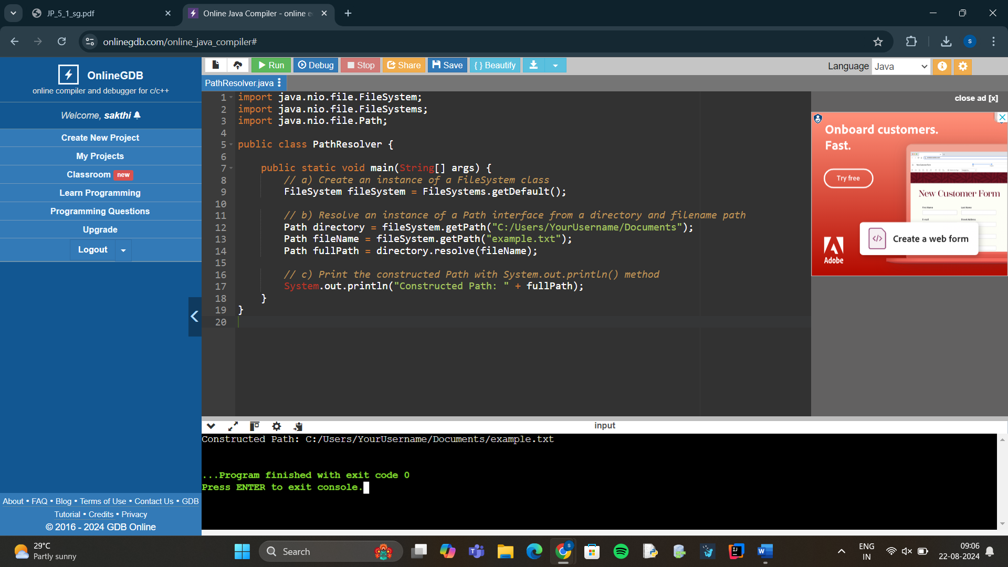

2.

import java.io.FileInputStream;

import java.io.IOException;

import java.io.ObjectInputStream;

public class AccountGenerator {

public static Object deSerialize() throws ClassNotFoundException {

Employee employee = null;

try (FileInputStream fileIn = new FileInputStream("employee.ser");

ObjectInputStream in = new ObjectInputStream(fileIn)) {

employee = (Employee) in.readObject();

System.out.println("Deserialized Employee: " + employee);

} catch (IOException i) {

i.printStackTrace();

}

return employee;

}

public static void main(String[] args) {

// Creating an Employee object

Employee employee = new Employee("John Doe", "E123", 50000.00);

// Serialize the Employee object

serializeData(employee);

try {

// Deserialize the Employee object

Employee deserializedEmployee = (Employee) deSerialize();

System.out.println("Employee after deserialization: " + deserializedEmployee);

} catch (ClassNotFoundException e) {

e.printStackTrace();

}

}

}

